
EDA实验报告

课题名称： | “123”滚动字幕
学 院： | 机电与信息工程学院
专 业： | 通信工程
年级班级： | 2012
姓 名： | 高楚阳
学 号： | 201200800568

- VHDL代码
Clock.VHD

LIBRARY IEEE;
USE IEEE.STD_LOGIC_1164.ALL;
ENTITY CLOCK IS
PORT(
RESET :IN STD_LOGIC;
CLK :IN STD_LOGIC;
Q0 :OUT STD_LOGIC_VECTOR(6 DOWNTO 0);
Q1 :OUT STD_LOGIC_VECTOR(6 DOWNTO 0);
Q2 :OUT STD_LOGIC_VECTOR(6 DOWNTO 0);
Q3 :OUT STD_LOGIC_VECTOR(6 DOWNTO 0);
Q4 :OUT STD_LOGIC_VECTOR(6 DOWNTO 0));
END;
ARCHITECTURE ONE OF CLOCK IS

TYPE FSM_ST IS (S0,S1,S2,S3,S4,S5,S6,S7);
SIGNAL current_state,next_state:FSM_ST;
SIGNAL DATA: INTEGER RANGE 0 TO 25000000;
SIGNAL CLKIN,Q: STD_LOGIC;
BEGIN

REG:PROCESS (RESET,CLKIN)
BEGIN
IF RESET ='0' THEN current_state<=S0;
ELSIF CLKIN='1'AND CLKIN'EVENT THEN
current_state<= next_state;
END IF;
END PROCESS;
COM:PROCESS(current_state,next_state)
BEGIN
CASE current_state IS
WHEN S0=>Q0<=not"0000000";Q1<=not"0000000";Q2<=not"0000000";Q3<=not"0000000";Q4<=not"0000000";
next_state<=S1;
WHEN S1=>Q0<=not"0000110";Q1<=not"0000000";Q2<=not"0000000";Q3<=not"0000000";Q4<=not"0000000";
next_state<=S2;
WHEN S2=>Q0<=not"1011011";Q1<=not"0000110";Q2<=not"0000000";Q3<=not"0000000";Q4<=not"0000000";
next_state<=S3;
WHEN S3=>Q0<=not"1001111";Q1<=not"1011011";Q2<=not"0000110";Q3<=not"0000000";Q4<=not"0000000";
next_state<=S4;
WHEN S4=>Q0<=not"0000000";Q1<=not"1001111";Q2<=not"1011011";Q3<=not"0000110";Q4<=not"0000000";
next_state<=S5;
WHEN S5=>Q0<=not"0000000";Q1<=not"0000000";Q2<=not"1001111";Q3<=not"1011011";Q4<=not"0000110";
next_state<=S6;
WHEN S6=>Q0<=not"0000110";Q1<=not"0000000";Q2<=not"0000000";Q3<=not"1001111";Q4<=not"1011011";
next_state<=S7;
WHEN S7=>Q0<=not"1011011";Q1<=not"0000110";Q2<=not"0000000";Q3<=not"0000000";Q4<=not"1001111";
next_state<=S3;
END CASE;
END PROCESS;
CLOCK: PROCESS(CLK)
BEGIN
IF RISING_EDGE(CLK) THEN
IF(DATA=24999999) THEN
DATA<=0;
Q<=NOT Q;
ELSE
DATA<=DATA+1;
END IF;
END IF;
CLKIN <= Q;
END PROCESS;

END ONE;

- RTL图
顶层图
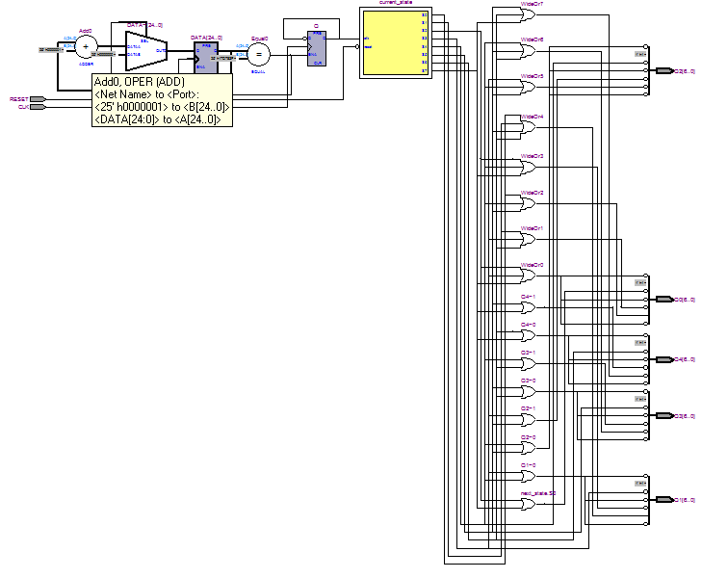

- 时序仿真波形图

